Developing Your Student Website
1. Go to www.weebly.com
2. On the left side enter the fields with the appropriate information
Full Name:
Email:
Password:

3. In the next window it will ask if you want a Site, Blog, or Store. Choose Site.
4. Select a Theme
The first step to create a site is to select a theme. We have well over a hundred themes to choose from and you can look over them by scrolling down our Choose a Theme page.
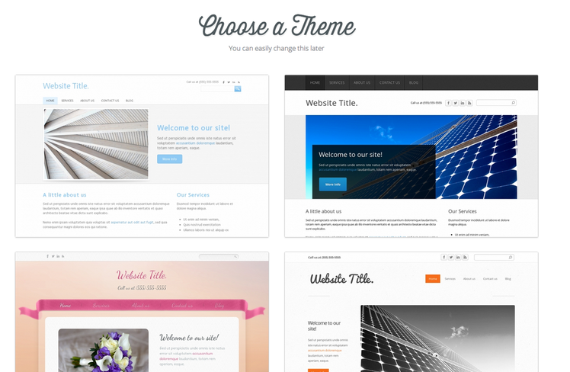
See a theme you like? Then you can click right on it to select it.
We know it can be a little overwhelming to choose exactly which theme you want before you've even started working on your site, but don't fret as you can very easily change the theme later (and we'll show you how). For now just find a theme that looks good and select it.
5. After you pick a theme you'll be asked to give your site a title.

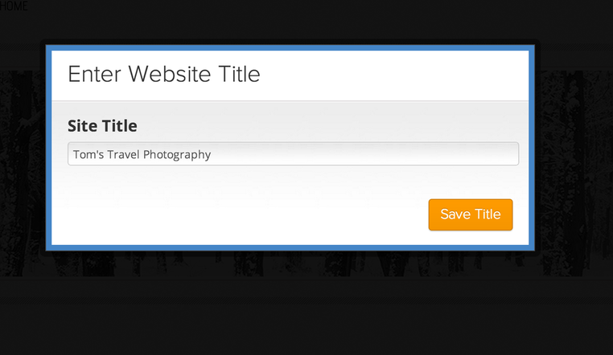

Your title should be: “Your First Name Mueller Charter Leadership Academy.” By the way, the title can be easily changed later on.

6. Next you'll choose your site's address (also called a domain). This isn't particularly important until you've finished your site and Published it. However, you must select “SubDomain” like in the picture below. Additionally, make sure your website domain is titled as such: mcla “your first name and last name initial”.weebly .com. Here is an example: mclagabyp.weebly.com

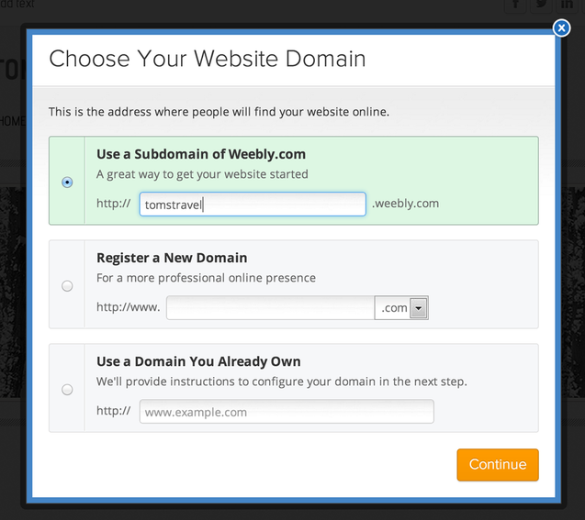

7. All done with the initial setup; you're now ready to start creating your site!
Go to this website to find more information:

http://kb.weebly.com/first-elements.html

